TP#: | MATC/NWD INTERNAL TEST PLAN | DATE: Sep 25th 2019 to Oct 04th 2019
Requestor: Adam Herrman
Test Description: AC RTD Hotline Inspection #7

Reason For Test: Experimenting with new flow in AC RTD using right the first time Hotline Inspections. Productivity gains from elimination of second visual cured tire inspection and reduction in rollbacks.

 | Plant: US11 | Test Area: US 11, AC RTD

Test Plan Description:
- Change 1 Aspect post to a Hotline Inspection post. The Hotline Inspector will inspect the outside of the tire and paint the tire, not repair it. If the tire requires an R1 or R3 repair the Hotline Inspector will re-inspect the repair area. The Hotline post must be manned by an FAA certified operator.
- Change 1 Aspect post to a repair post. The repair operator will perform R1 repairs and then send the tire back to the hotline.
- The R3 repair operator must send their repairs back to the Hotline for re-inspection.
- Change 1 Final Inspection post to a Final Liberation post. The Final Inspector will inspect the inside of the tire and perform final liberation. The Final Liberation post must be manned by an FAA certified operator.
Operator Responsibilities:
Cureman (Located at Curing post):
- Trim rind
- Trim vents
- Normal cureman duties
R1 Repairman (Located at 2nd Aspect post):
- R1 Repairs
- Branding after completing a repair
- R1 post LEA data entry
R3 Repairman (Located at 2nd Aspect post):
- R3 Repairs
- Branding after completing a repair
- R3 post LEA data entry
Hotline Inspector (Located at 1st Aspect post):
- Inspection of outside of tire
- Inspection of R1 repairs
- Inspection of R3 repairs
- Tire classification
- Commercial and military information verification
- Apply ANT stickers to DAL tires
- Returned good Inspection (same as normal inspection)
- Aspect post LEA data entry
- Pool changes
- Mold Interventions
- 698s and Curelaws
- Paint bias tires
- Apply red balance dot to bias tires
- Record white label tire S/Ns for test
Final Liberation Inspector (Located at Radial Final Inspection post):
- Inspection of inside of tire
- Release tire in LEA at Final liberation
- 8130 labels
- Record white label tire S/Ns for test
Disposition of Tires/Materials: A white label will be placed on all tires involved in the test. Only the final inspectors involved in the test will be allowed to release the tires with white labels. Once the tires have been counter verified the white labels can be removed by the C3p.

Criteria for Success: Final inspector leak rates must remain below 2% when counter verified by the C3p. 50 bias tires, must be counter verified. Shop must be able to keep pace with curing. At least .5 suppressions after TPUs have been updated.

Required Data: Beginning and ending of shift white label WIP levels for Aspect, Shearo, and Final Inspection. Hotline and Final Liberation leak rates.

Study Diagram:
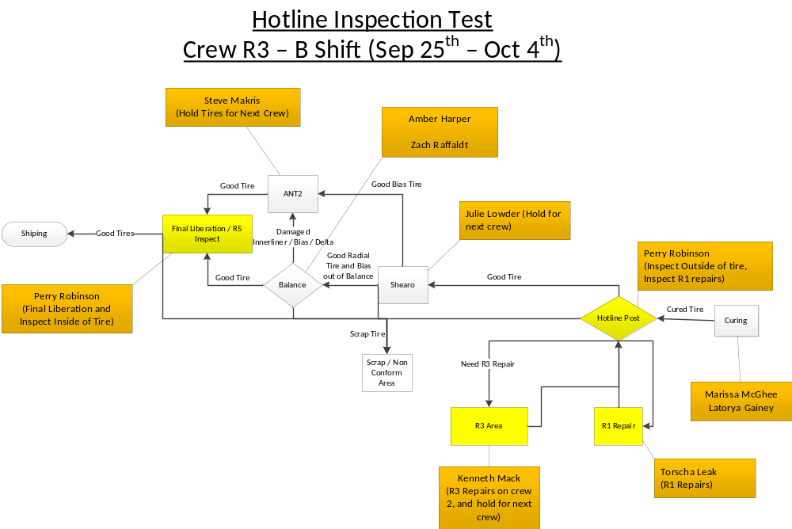
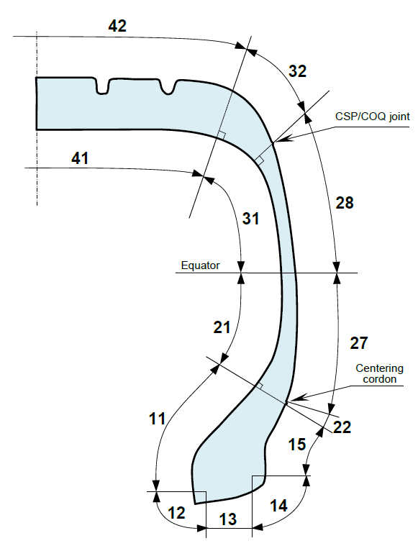
Sectors: 13, 14, 15, 22, 27, 28, 32, and 42 are defined as the outside of the tire.
Sectors: 12, 11, 21, 31, and 41 are defined as the inside of the tire.

REVIEW/APPROVALS
Originator: Adam Herrman - RTD Area IE
US11 RGQA: Pedro Ruiz
US11 IE Mgr: Simon Goring
US11 RTD Shop Mgr: Reggie Sasser
US11 RTD BUL: Chad Mabry

Summary of the Test Results:

